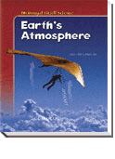
Notes Packet
Chapter 4
Climate
is a
Long-Term Weather Pattern
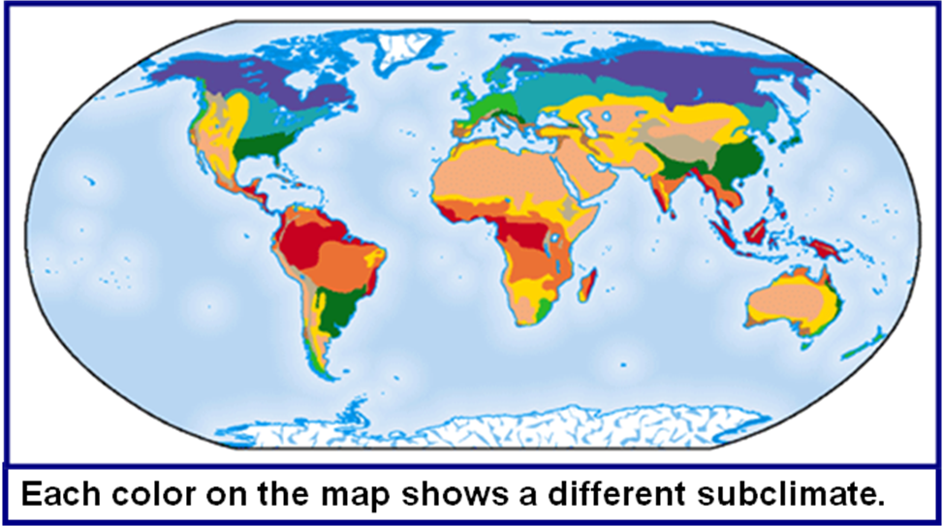
Textbook and Online Activity
CLIMATE
and
CLIMATE ZONES
Chapter 4 Climate is a Long-term Weather Pattern
geography Affects Climate  p 117 - 121 | Notes
Climate Definition  Factors Affecting Temperature  Take NOTES for each factor  Your notes should demonstrate an understanding of the factors.  Key Vocabulary Words:  _______________________  _______________________  _______________________  _______________________  _______________________  _______________________ | List 4: look at the headings  1.  2.  3.  4.  For each factor  Notes:  Notes:  Notes:  Notes:
seasonal Changes are part of climate  p 122 – 123  and online | Notes (3 facts per heading)
Definition of Seasons  Patterns Affecting Climate  Take NOTES for each factor  - TEMPERATURE  - PRECIPITATION  Key Words:  Find the Definitions On-line  LEEWARD  WINDWARD  RAIN SHADOW  Factors Affecting Precipitation  - Prevailing Winds  - Mountains | List 2: look at the headings  1.  2.  For each factor  Notes:  Draw a Picture Windward and Leeward Winds  Notes:

OCEAN CURRENT MAPS
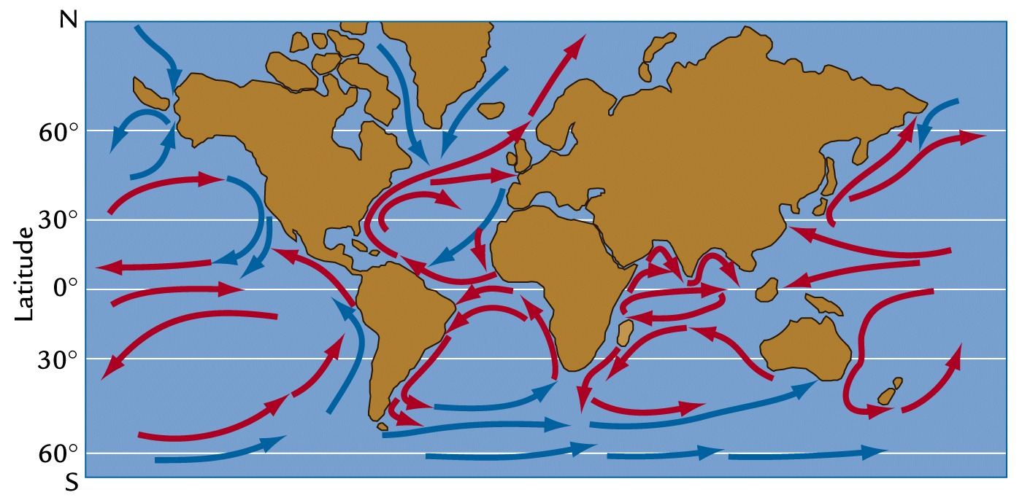

Why are there Ocean Currents? _________________________________________________________________

_________________________________________________________________

How are Ocean Currents similar to Global Winds?

_________________________________________________________________

How are Ocean Currents different from Global Winds?

_________________________________________________________________

_________________________________________________________________

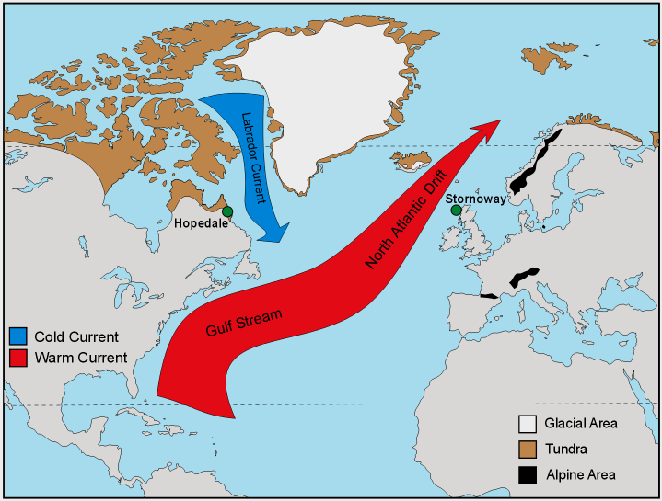
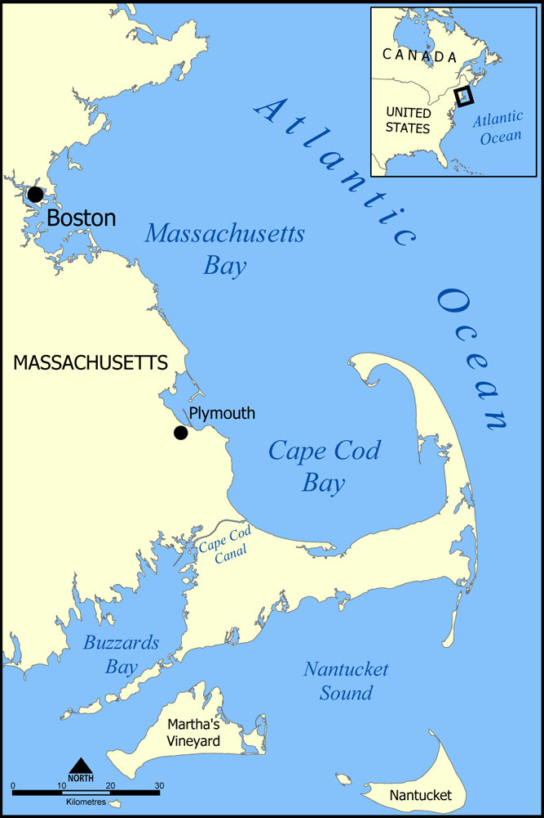
WARM
COLD
Labrador Current - cold
Gulf Stream - warm

How do Ocean Currents affect the east coast of the United States? __________________________________________________________________________

Hopedale and Stornoway are at the same latitudes, but very different climates. Explain why they are so different.
____________________________________________________________________________________________________________________________________________________________________

How do the waters of Nantucket Sound and Buzzards Bay compare in temperature to those of Cape Cod Bay? (Think of your own experiences in summer at the beach!)
____________________________________________________________________________________________________________________________________________________
Why are the waters of Nantucket Sound and Buzzards Bay warmer than those of Cape Cod Bay? Name the currents. ____________________________________________________________________________________________________________________________________________________________________

On this page, answer QUESTIONS 1-5 from page 123 in your textbook.
Question 1:

Question 2: SKIP THIS QUESTION

Question 3:

Question 4:

Question 5:

Computer Activity:
- Log onto the following web site: http://weatherbase.com/
- Find a chart of the yearly temperature and precipitation averages for Hyannis, Massachusetts.
- Find a chart of the yearly temperature and precipitation averages for Denver, Colorado.

Average Temperature HYANNIS Latitude: Elevation:

 |  | YEAR |  | Jan. |  | Feb. |  | Mar. |  | Apr. |  | May |  | Jun. |  | Jul. |  | Aug. |  |  | Sep. |  | Oct. |  | Nov. |  | Dec.
°F |  | .
Average Temperature DENVER Latitude: Elevation:

 |  | YEAR |  | Jan. |  | Feb. |  | Mar. |  | Apr. |  | May |  | Jun. |  | Jul. |  |  | Aug. |  | Sep. |  | Oct. |  | Nov. |  | Dec.
°F |  | .
Average Precipitation HYANNIS

 |  | YEAR |  | Jan. |  | Feb. |  | Mar. |  | Apr. |  | May |  | Jun. |  | Jul. |  |  | Aug. |  | Sep. |  | Oct. |  | Nov. |  | Dec.
in
Average Precipitation DENVER |  |  |  |  |  |  |  |  |  |  |  |  |  |  |  |  | Years on Record: 30

 |  | YEAR |  | Jan. |  | Feb. |  | Mar. |  | Apr. |  | May |  | Jun. |  | Jul. |  | Aug. |  | Sep. |  | Oct. |  | Nov. |  | Dec.
in

What are the factors that may affect the TEMPERATURESs of HYANNIS AND DENVER?
HYANNIS | DENVER
What are the factors that may affect the PRECIPITATION of HYANNIS AND DENVER?
HYANNIS | DENVER

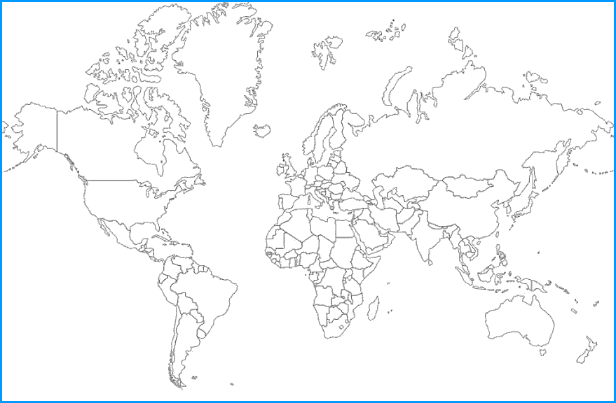
Find a map of Climate Zones, online or in your text.
. Create your own colored map with a key.
Concept Map

Long Term
Climate Changes
Ice Ages

Evidence for Climate Change
Causes of Climate Change

Facts

Why were the oceans lower during the ice ages than they are now?

Why would the movements of the continents affect the overall climates of different regions?

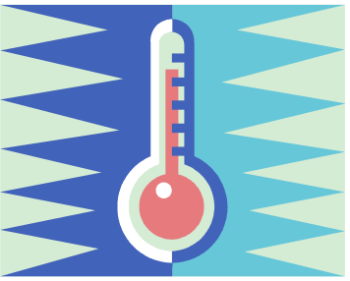
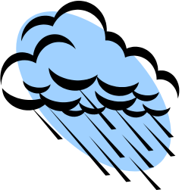
TEMPERATURE
PRECIPITATION
__
FACTORS AFFECTING CLIMATE
PRECIPITATION
DENVER, CO

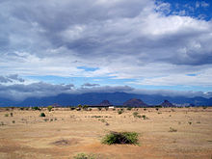
TEMPERATURE
__
FACTORS AFFECTING CLIMATE
PRECIPITATION
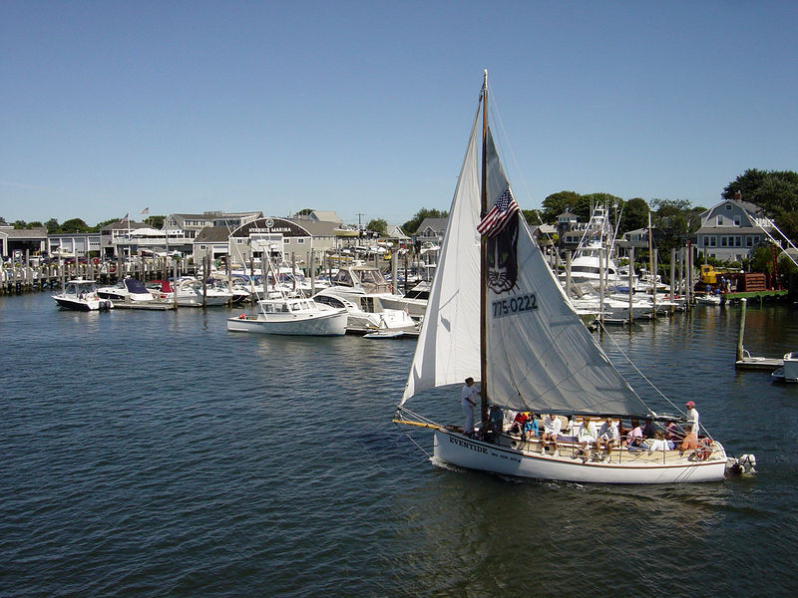
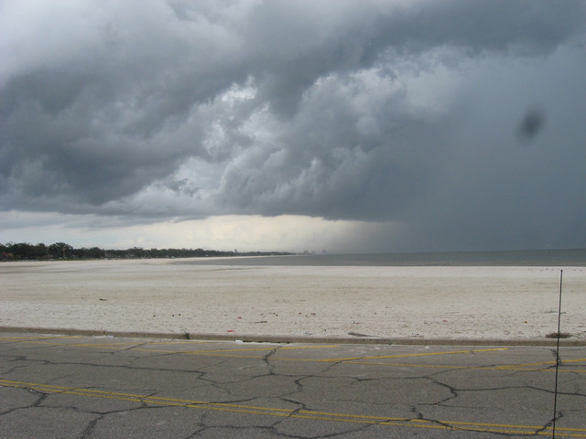
LATITUDE
TEMPERATURE
HYANNIS, MA

