# cropped-lasilla_panorama_fk-normal

# ***Overview of 2016-17 Grade 8 Science***

Mr. Ruggiero

**Classroom Website:** [**http://bmsscience8209.edublogs.org/**](http://bmsscience8209.edublogs.org/)

**Twitter: @MrRuggieroBMS**

**Welcome to the Wonderful World of Grade 8 Science!**

I am looking forward to a terrific and exciting year with your children. Here is a list of the topics and textbooks we will use:

|  |  |
| --- | --- |
| **Mapping the Earth** | ScienceSaurus/Earth’s Surface |
| **Earth Science** | The Changing Earth / Earth’s Surface |
| **Climate & Climate Change** | Earth’s Atmosphere |
| **Astronomy** | Space Science |
| **All Topics** | ScienceSaurus |

There will be notes, handouts and computer resources as we move through the topics. You will also be asked to provide materials and articles on your own that you may find that best fit the topics we are discussing. We will not be covering every section in each book, but you are responsible for what we do cover.

***Please cover each textbook as they are given to you. This will be the easy homework!***

|  |  |
| --- | --- |
| **Everyday Classroom Materials** | * ***Covered*** Textbook * Composition Book (Cow Book) * 3-Hole Punch Folder or Binder for Handouts/Papers * **Pens or Pencils** * Pencil Sharpener |
| **Occasional Classroom Materials**  **(Keep in the locker)** | * Colored Pencils/Markers * Rulers * Calculators |

I expect you to keep all your work organized, and be prepared for ***EVERY*** class. I would be glad to suggest ways to do so. You should have a ***Science Only 3-Hole*** folder for homework, handouts and assignments. Lab exercises and other activities may be done on the computer, on paper or what I provide. It’s your responsibility to stay organized and have all materials when you need them!

The ***Cow Composition*** book is for daily *Cow Book Questions*.

MCj04042630000[1]**Essential Question*Components of the Science Grade***

How does this relate to the world around you?

***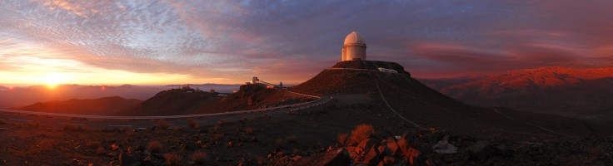***

***Unit Assessments and Projects (40%)***

***Quizzes, WORMS Chapter Tests (30%)***

***Classwork (20%)***

***Homework (10%)***

…together make up the student’s total assessment. They will all count unless otherwise specified. There will generally be several small quizzes, and at least one lab and chapter test per unit. Occasionally, alternative assessments will be given in lieu of traditional tests (writing assignments, projects, research, and posters, WORMS.)

Homework *will* account for 10% of the grade. Homework will be assigned frequently, but not every night, and can always be found on the board, on a link on the class website to the Team 8-2 Homework Web Page, or at

<https://sites.google.com/a/bourneps.org/bms-team-8-2/home>

Most assignments will be checked in class on the due date for credit.

***Homework is assigned as a preparation for a class activity.***

Typically it is simply the writing of vocabulary words ands definitions to prepare for the next day discussion. ***Students may have homework of differing complexity and challenge, but all students are responsible for their assignment.***

***Any three (3) missing homeworks, no matter when they occur, will result in an after-school detention and mandatory make-up.***

***No make-up credit on missing homeworks unless you are absent!!***

**Missing** or **incomplete** assignments will result in reduced grades.

*For terms 1*, a full grade will be deducted for each late day.

*For terms 2-4,* no late work will be accepted, and a grade of 0 will be earned for the assignment*.*

Occasionally there will be allowances for a “***Get Out of Homework Free***” card, which can be earned by special tasks, or completing all homework in a specific time period. These cards cannot be earned for an assignment due that day.

**Make Up Work**

If a student is absent, he/she must get their make-up work from me. Students must always check with me, even if they have received the work from friends or from the **web site**. Students will take responsibility to schedule time for make-up tests, quizzes or labs.

For extended absences, work not completed within the 2 week period, as per the Student Handbook, will result in a zero for the assignment.

**Edit for Credit**

* Students earning a D or lower on an assessment will have the opportunity to “**Edit for Credit**” in Terms 1 and 2. Basically, students will self-analyze their errors on assessments, perform a remedial activity, and then can retake the same or amended assignment for a higher assessment grade.
* Terms 3 and 4 will model high school grading practices.
* Unit Assessments and Projects are not eligible for Edit for Credit.

***Student Expectations and Responsibility***

******

**Behavioral Expectations**

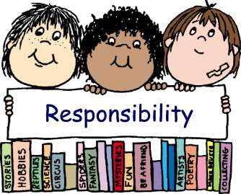TEACHING IS MY RESPONSIBILITY…

…LEARNING is your responsibility

You are all now teenagers, and with age comes responsibilities and expectations, as well as opportunities for privilege and empowerment. Respect for each other is a must. That is an expectation of all students. I also expect that all students assume responsibility for their actions, their work, their behavior and all aspects of themselves. You will have choices, but with choice comes consequence. You are now old enough and wise enough to weigh the options.

You are young adults, and will be treated as such. My responsibility is to provide to you, and you should expect from me, respect, fairness, honesty, an enthusiasm for teaching, and my providing the very best environment for your learning.

Doing work on time is your responsibility

Tests, quizzes, and labs will be collected, graded and handed back in a timely fashion. Homework will generally not be collected, but it will be checked in class most days.

MISSING WORK is your responsibility

I will generally be available most days after school, and will specify a certain day of the week for planning purposes. Students can reach me to schedule time for extra help or make-up at any time. Let me know by NOON of that day if you are staying after school and sign up on the After-School sheet on the board.

Guardians/Parents can reach me easily at any time of the day through email, and is the *preferred* method of initial contact! My address is [rruggiero@bourneps.org](mailto:rruggiero@bourneps.org)

Please allow 24 hrs for a response. If you wish to speak to me personally, please call me at the school after 2:30, Tuesday through Friday at 508-759-0690 x 241.

Old-fashioned written notes work well too! Please be sure to include the appropriate contact information, such as phone number, email, and best time to call, with any method you choose!

**Mr. R's BMS Science 8 Twitter and Remind**

Thereis a classroomTwitter site **@MrRuggieroBMS** that we use for the classroom and some communication, especially on projects and over vacation periods. You can get to it by clicking on the link in the upper right hand side of the classroom web site.

We also use REMIND for communication. <https://www.remind.com/join/h87cfc>

**Room 241**

**Classroom Guidelines for Thinking Behaviors**



**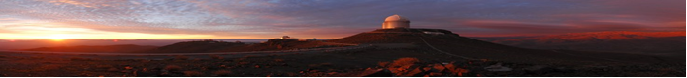**-

* I will participate
* I will give reasons for answers
* I will take time to think about the problem
* I will use precise, specific words
* I will listen to what other students have to say
* I will offer different answers to one problem
* I will think about my thinking
* I will stick with a problem, even though it is difficult
* I will ask complex questions about the topic

**Earth Science 8**

Students in eighth grade learn about the Earth Sciences: *topography, geology, weather and climate, and astronomy*. Students examine and investigate the planet Earth, specifically focusing on mapping the Earth, the Earth’s structure, heat transfer in the Earth’s system including plate tectonics and atmospheric conditions, the Earth’s history, and the Earth in the solar system. Students learn that the Earth is only one object in space as they delve into astronomy to investigate a vast universe governed by physical laws.

This course reinforces the basic concepts learned in the earlier years such as forms of energy, density, and heat transfer, by applying their knowledge to content in the Earth Sciences. At the end of each unit, students will engage in higher thinking skills by completing a summative performance exam that allows them to analyze what they have learned, relate their knowledge to the real world, and apply their learning in a creative unit assessment project.

**Program of Studies**

***Signs of Success…***

Here are the elements of a Successful 8th Grade Science Experience:

* A planner where daily homework assignments and long term assignments are recorded and checked off each day
* A covered science textbook, a cow book and a binder that are used each night
* Mastering the Vocabulary
* Edit for Credit
* Assessments (1-2 per week)
* Scheduled appointments for make-up work
* Responsible Behavior and Study Habits
* A Love of Science
* And Having Fun!

Please read this overview, share with home, ask for your parents’/guardians’ signature, and return to me.

This will then be kept in your Science folder. Remember that this is an overview, and that I can meet with anyone to discuss anything at any point in the school year.

***Let’s have a terrific year together!***

*Please make a checkmark in the 2 spaces below, and then sign below. Many thanks*!

***\_\_\_\_I have read and understand all of the course expectations for***

***Mr. Ruggiero’s 2016 – 17 Grade 8 Science classes.***

# ***I* \_\_\_ do \_\_\_do not *give permission for photos of my child’s classroom activities to be posted on the classroom web site.***

*Student \_\_\_\_\_\_\_\_\_\_\_\_\_\_\_\_\_\_\_\_\_\_\_\_\_\_\_\_\_\_\_\_\_\_\_\_\_\_\_\_\_\_\_\_\_\_\_\_\_\_\_\_\_\_\_\_\_*

*Parent/Guardian \_\_\_\_\_\_\_\_\_\_\_\_\_\_\_\_\_\_\_\_\_\_\_\_\_\_\_\_\_\_\_\_\_\_\_\_\_\_\_\_\_\_\_\_\_\_\_\_\_\_\_*

Return this last page signed by parent or guardian to school for your first homework assignment, and keep the packet in your Science Folder for reference.